Abstract—These instructions give you guidelines for preparing your two page abstract which will be published on the homepage of CCA 2012. Use this document as a template if you are using Microsoft Word 6.0 or later. Otherwise, use this document as an instruction set. You will need to submit your paper as Word or Adobe Acrobat PDF format file via email to cca2012@itep.kit.edu. All submissions must be formatted for DIN A4 size (21 cm × 29.7 cm). Only electronic submissions will be accepted.
Preparation of Two Page Abstract for CCA 2012
First A. Author and Second B. Author
Affiliation (all on one line if possible)

Third C. Author
Affiliation (all on one line if possible)

Key Words—About four key words separated by commas should be inserted under the abstract.

INTRODUCTION
Follow the type sizes specified in Table 1 as best you can. Use a proportional, serif typeface such as Times or Dutch Roman. Avoid sans serif typefaces such as Swiss or Helvetica. If your paper is longer than 2 pages, you may shorten it by using a slightly smaller type size for the main text.

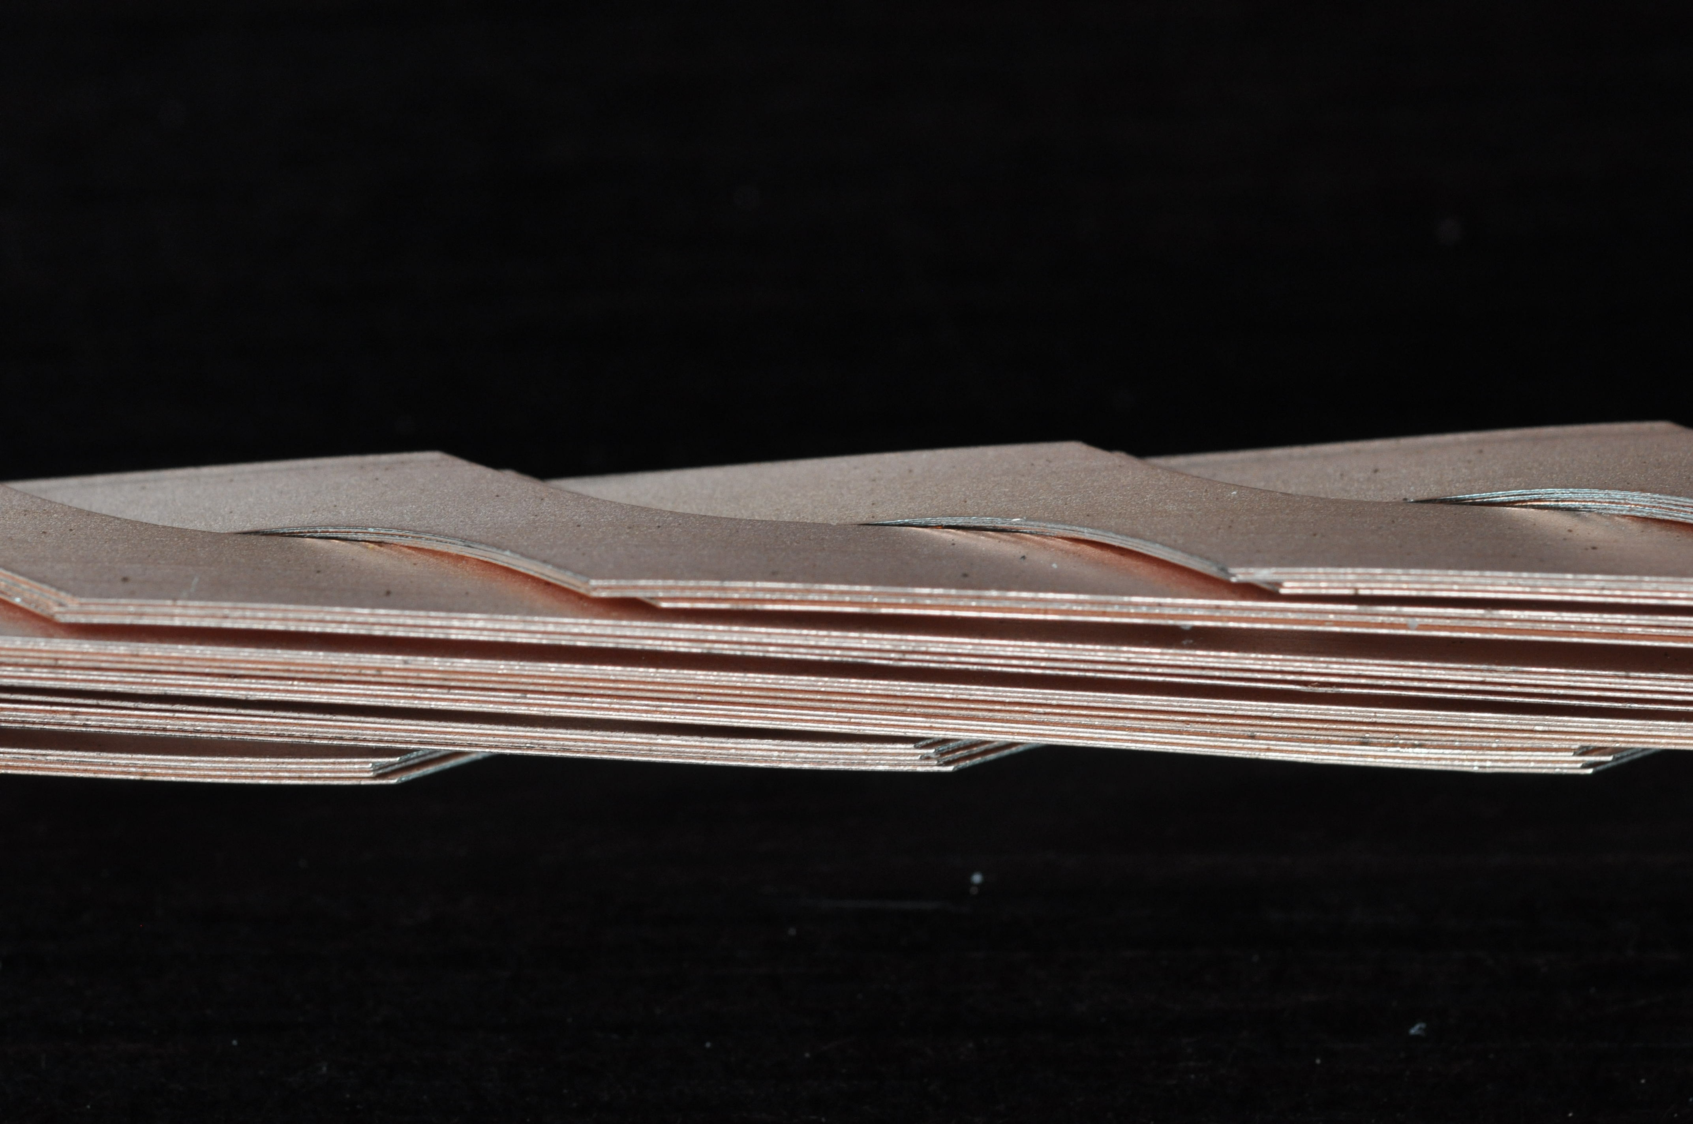
Fig. 1. This line is the figure subtitle.
This template is set up for US letter configuration, which should be used for the required electronic submission. Non-Word users should set the margins in accordance with those shown in Table 2.
TABLE 1 TYPE STYLES AND POINT SIZE
Points | Times Roman Font | Bold | Italic
8 | References, tables, table names, table subtitles, figure captions, footnotes
9 |  | Abstract, key words
10 | Authors’ affiliations, main text, equations |  | Sub-heading
11 | Authors’ names
18 |  | Paper title

TABLE 2 MARGIN REQUIREMENTS
Margin | US Letter Paper
Top | 18 mm (0.70 in)
Bottom | 18 mm (0.70 in)
Left | 17 mm (0.65 in)
Right | 17 mm (0.65 in)

HELPFUL HINTS

Example for Equations

$\int_{0}^{∞}{\text{exp}(−λ |z_{j}}−z_{i}|) λ^{−1}J_{1}(λ\text{}r_{2}) J_{0}(λ\text{}r_{i}) dλ \text{}$ (1)

Example for Figures
Acknowledgment

References
- Authors’ Names, Journal, vol. #, pp.1-3 , October 2007.
- Authors’ Names, Journal, vol. #, pp.4-6 , October 2007.
- Authors’ Names, Journal, vol. #, pp.7-9 , October 2007.
- Authors’ Names, Journal, vol. #, pp.10-12 , October 2007.
- Authors’ Names, Journal, vol. #, pp.13-15 , October 2007.

